**Assignment 2 Report**

**Name:** Dang Khoa Le  
**Student Number:** 103844421  
**Tutorial:** Tuesday 9.30-10.30 AM

**Task 1: Constructing and Justifying Six Concrete Test Cases**

**Test Case 1: Mixed Positive and Negative Numbers**

* **Input:** [10, -9, 15, 7, 1, -5, 28]
* **Expected Output:** Negative numbers: [-9, -5], Positive numbers: [1, 7, 10, 15, 28]
* **Purpose:** Tests program's ability to correctly split and sort a mixed list of positive and negative integers. Validates the correct categorization of integers (positive and negative).

**Test Case 2: All Negative Including Zero**

* **Input:** [-1, -20, -3, 0, -6]
* **Expected Output:** Negative numbers: [-20, -6, -3, -1, 0], Positive numbers: []
* **Purpose:** Checks the program’s handling of the number zero (considered negative), along with duplicate values. Ensures that the list of positive numbers is correctly output as empty.

**Test Case 3: All Positive with Duplicates**

* **Input:** [5, 23, 5, 23, 42]
* **Expected Output:** Negative numbers: [], Positive numbers: [5, 23, 42]
* **Purpose:** Tests the program’s ability to handle a list of only positive numbers with duplicates, ensuring duplicates are removed and the list is correctly sorted.

**Test Case 4: Single Negative Number**

* **Input:** [-2]
* **Expected Output:** Negative numbers: [-2], Positive numbers: []
* **Purpose:** Verifies the program's functionality with the smallest input size, focusing on correct handling and output of a single negative number.

**Test Case 5: Edge Cases with Maximum Limit**

* **Input:** [1, -1, 2, -2, 3, -3, 4, -4, -5, -5, 6, -6, 7, -7, 8, -8, 9, -9, 10, -10, 11, -11, 12, -12, 13, -13, 14, -14, 15, -15]
* **Expected Output:** Negative numbers: [-15, -14, -13, -12, -11, -10, -9, -8, -7, -6, -5, -4, -3, -2, -1], Positive numbers: [1, 2, 3, 4, 5, 6, 7, 8, 9, 10, 11, 12, 13, 14, 15]
* **Purpose:** Tests the program's capability to handle the maximum limit of integers, verifying sorting and duplicate removal for both positive and negative lists.

**Test Case 6: Edge Case with Minimum and Maximum Integers**

* **Input:** [-100, 100, -100, 100, -100, 100]
* **Expected Output:** Negative numbers: [-100], Positive numbers: [100]
* **Purpose:** Verifies that the program can handle edge values of the input range, especially when duplicates of the extreme values are present.

**Task 2: Selection of a Single Test Case for Testing**

* **Scenario:** Suppose that due to testing resources, we can only afford to test the program with one and only one test case among the 6 test cases proposed in Task 1.
* **Selected Test Case:** Test Case 5
* **Justification:** This test case is the most comprehensive as it tests the program’s response to the maximum input size, ensuring proper functionality under stress conditions. It encompasses both positive and negative integers, checks the sorting order, and the correct categorization of numbers into two lists. This test case ensures broad functionality coverage and robust testing of key features.

**Task 3: Testing with the Python Program**

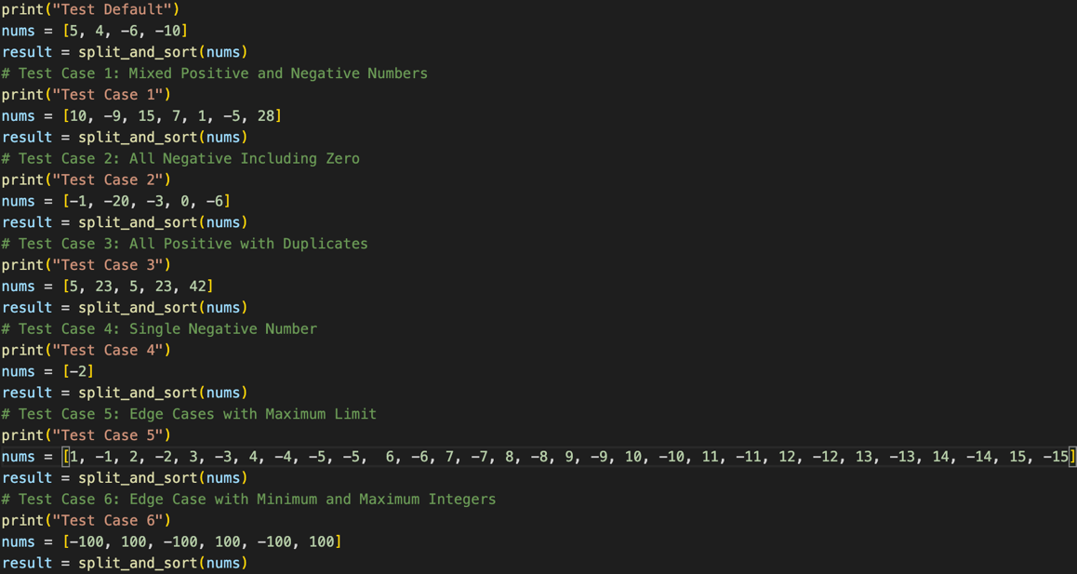**Test case inputs implementation:**

A set of 6 test cases’ input from Task 1 with the method to call for the split_and_sort function from assignment2.py and print method to categorize each different test cases are initialized at test.py Python script file and defined as the above figure. Also, instead of return a string of error message as given from the provided source code assignment2.py (which does not actually print the error message), we use the print method to print the error message to the terminal console instead.

**Test Execution and Results:**

1. **Test Case 1:** Passed - Output as expected.
2. **Test Case 2:** Failed - The program returned an error "Error: The number 0 is not a valid input."
3. **Test Case 3:** Failed - Output existed duplicated component.
4. **Test Case 4:** Passed - Output as expected.
5. **Test Case 5:** Failed - The program returned an error "Error: Input list should a smaller number of integers."
6. 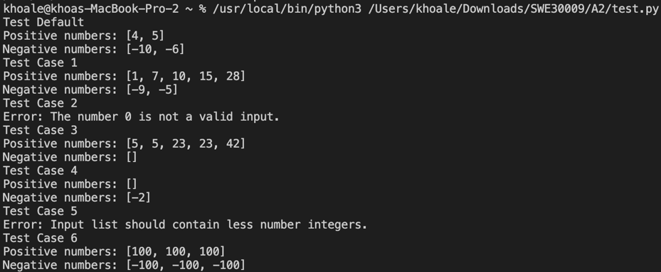**Test Case 6:** Failed - Output existed duplicated component.

**Reflection:**

* Error message wasn’t printed out due to the usage of return method, which has been changed to be used with a simple print method instead.
* The program did not handle the zero correctly despite the requirements specifying it should be treated as negative.
* The error handling for the maximum number of inputs is incorrect (only 20) as per the assignment description (should handle up to 30 integers).
* The program did not remove the duplicated number components.

**Suggested Improvements:**

* Modify the program to correctly handle zero as a negative number.
* Update the check for the maximum number of integers to allow up to 30 instead of the current limit, which appears to be incorrectly set at 20.
* 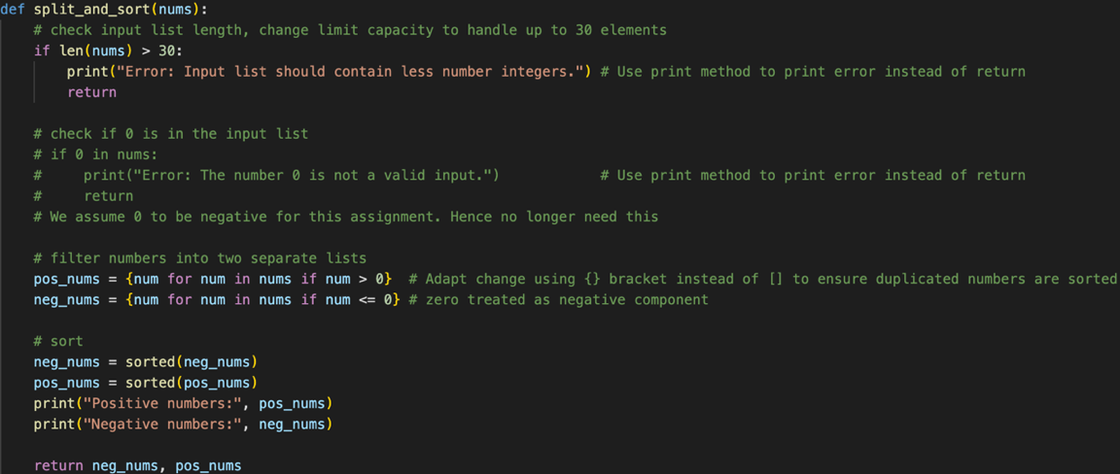Set a more proper set comprehensions using ‘{}’ bracket instead of ‘[]’ to ensure numbers are sorted appropriately and removes duplicated components.

Updated program (from assignment2.py) is provided as above figure.

**Final Program Test Execution and Results:**

* **Test Case 1:** Passed - Output as expected.
* **Test Case 2:** Passed - Output as expected.
* **Test Case 3:** Passed - Output as expected.
* **Test Case 4:** Passed - Output as expected.
* **Test Case 5:** Passed - Output as expected.
* A computer screen shot of a black screen

  Description automatically generated**Test Case 6:** Passed - Output as expected.

**Conclusion:**

The testing revealed significant issues with the program, include handling specific edge cases, particularly with removing duplicated component, zero handling and the input size limit.

Upon adjusting the program from assignment2.py, the test result returns accurate outputs of data as expected.